Aim:

To get temperature and humidity values (generated with random function to a variable) and write a condition to continuously detect alarm in case of high temperature

Code:

import random

import time

while True:

temp=random.randint(0,90)

humd=random.randint(20,70)

if temp>30:

print("temperature is :",temp)

print("humidity is:",humd)

time.sleep(3)

elif temp>40:

print("temperature is:",temp)

print("alaram on")

time.sleep(1)

else:

print("alaram off")

output:

temperature is : 48

humidity is: 55

temperature is : 90

humidity is: 66

temperature is : 57

humidity is: 43

temperature is : 42

humidity is: 32

temperature is : 59

humidity is: 47

temperature is : 42

humidity is: 25

alaram off

temperature is : 80

humidity is: 35

alaram off

temperature is : 55

humidity is: 50

temperature is : 59

humidity is: 42

alaram off

temperature is : 77

humidity is: 48

temperature is : 42

humidity is: 63

alaram off

alaram off

program screen:

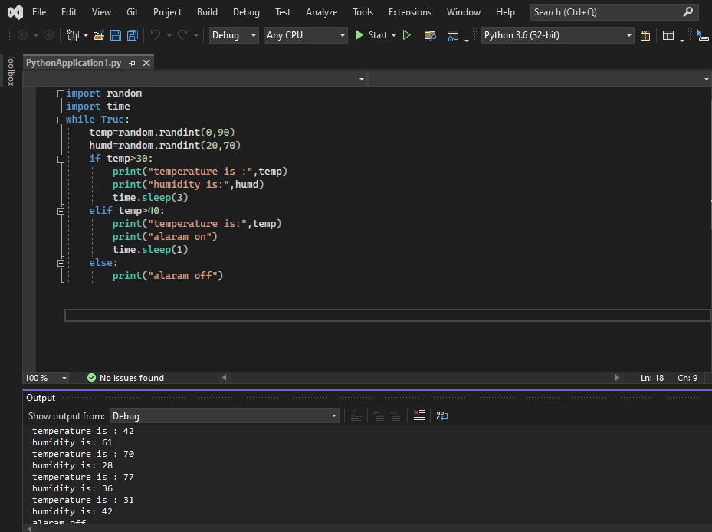

Output screen:

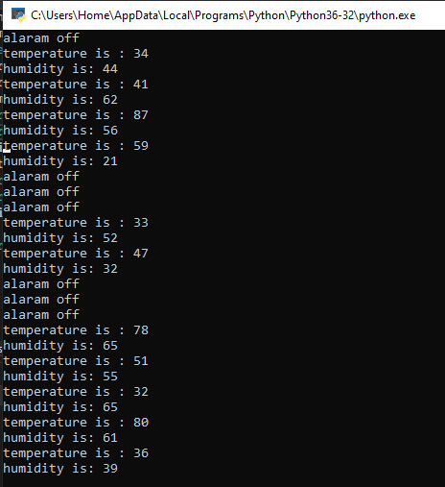

Result:

Thus temperature and humidity values are derived and alarm is detected at high temperature.